Workshop5
Name: JIAQI YANG
Student ID: [682131020]

Workshop5
Step 1: Data Loading, Missing Value and Outlier Handling 1
1.1Data Loading 1
1.2Missing Value Detection 1
1.3Feature Engineering (Text/Time to Numerical Features) 2
1.4Outlier Removal (IQR Method) 2
1.5Visualizations for Step 1 2
Step 2: Perform EDA (3 points) 3
2.1Distribution of Numerical Features 3
2.2Correlation Heatmap 4
2.3Top 10 Most Active Usernames 5
2.4 EDA Summary 5
Step 3: Scaling using Standard Scalar (1 point) 6
3.1 Scaling Purpose 6
3.2 Scaling Validation 6
Step 4: Modelling with K-Means and Hierarchical Clustering (2 points) 7
4.1 Dataset Sampling Note 7
4.2 Tentative Clustering (k=3) 7
4.3 Initial Findings 7
Step 5: Find Optimal Number of Clusters (1 point) 8
5.1 Elbow Method 8
5.2 Silhouette Score 9
5.3 Optimal k Selection 9
5.4 Optimal Clustering Results 10
Step 6: Discussion of Findings + Extra Credit (Dendrogram) (2 points + 2 extra) 11
6.1 Extra Credit: HAC Dendrogram 11
6.2 Cluster Feature Means 12
6.3 Cluster Visualization 12
6.4 Cluster Interpretation 13
6.5 Key Conclusions 13

Step 1: Data Loading, Missing Value and Outlier Handling (1 Point)

1.1Data Loading
The dataset used in this workshop is a Twitter tweet dataset (workshop_km.csv) with 1,048,575 rows and 4 original columns (timestamp, fixed_col, username, tweet). The dataset was loaded using pandas.read_csv() with encoding='latin-1' to avoid Unicode decoding errors (common for Twitter historical data).

1.2Missing Value Detection
A missing value check was performed on the dataset, and the result showed 0 missing values across all columns. No missing value imputation or deletion was required.

1.3Feature Engineering (Text/Time to Numerical Features)
Since the original dataset only contains text/categorical features (unfit for clustering), 6 numerical features were extracted for subsequent analysis:
- hour: Hour of the day (0-23) extracted from timestamp (PDT time zone)
- minute: Minute of the hour (0-59) extracted from timestamp
- tweet_length: Character length of each tweet
- word_count: Number of words in each tweet (extracted via regex) mention_count: Number of @user mentions in each tweet
- url_count: Number of URLs in each tweet

1.4Outlier Removal (IQR Method)
Outliers in the 6 numerical features were detected and removed using the Interquartile Range (IQR) method (Q1 - 1.5IQR to Q3 + 1.5IQR). After outlier removal:
- Original data volume: 1,048,575 rows
- Cleaned data volume: 1,007,098 rows (96.02% retention rate)

1.5Visualizations for Step 1
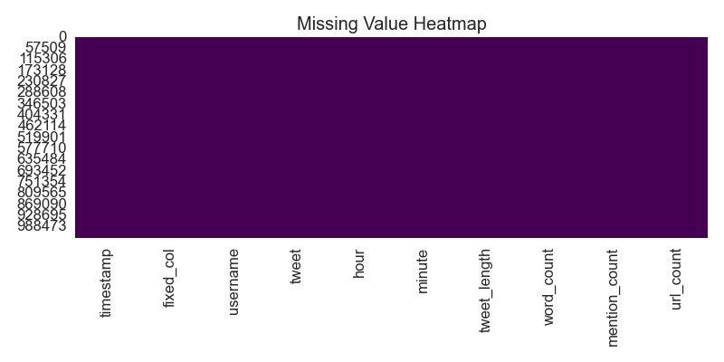
Missing Value Heatmap (No missing values detected)

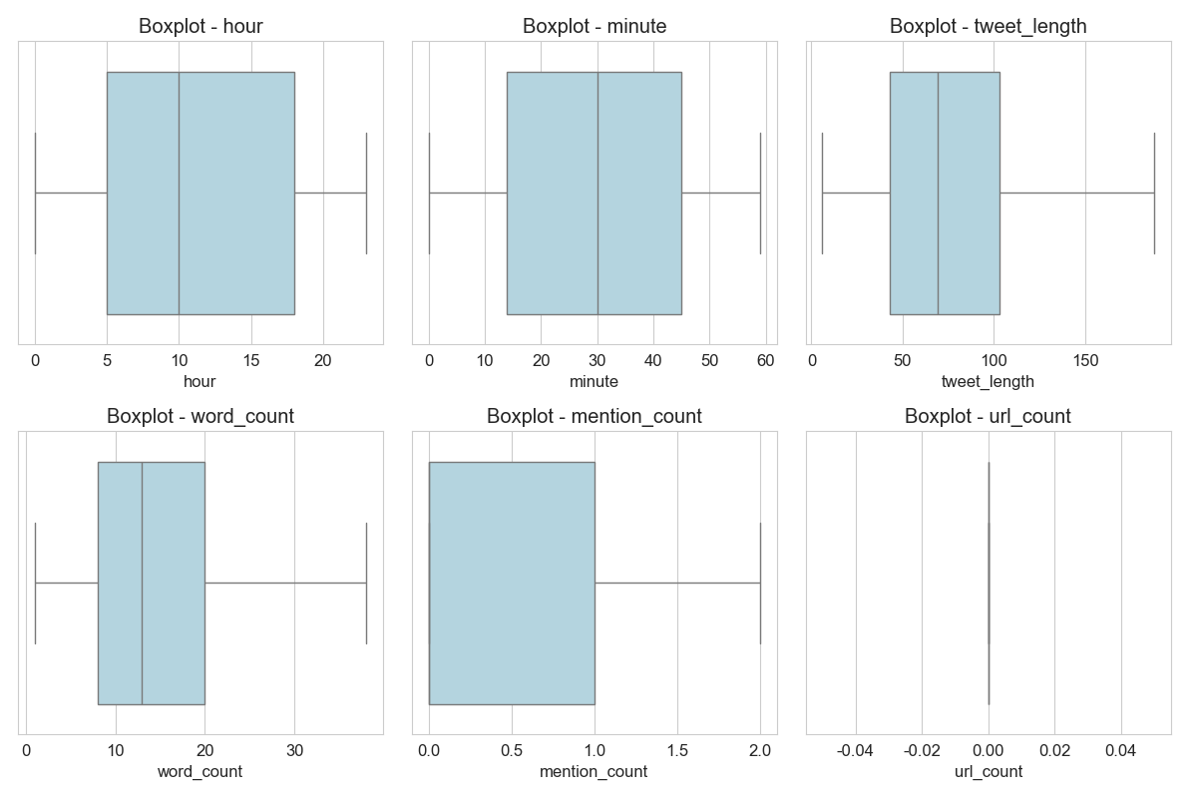
Boxplots of Numerical Features After Outlier Removal (Distributions are concentrated without extreme values)

Step 2: Perform EDA (3 points)

2.1Distribution of Numerical Features
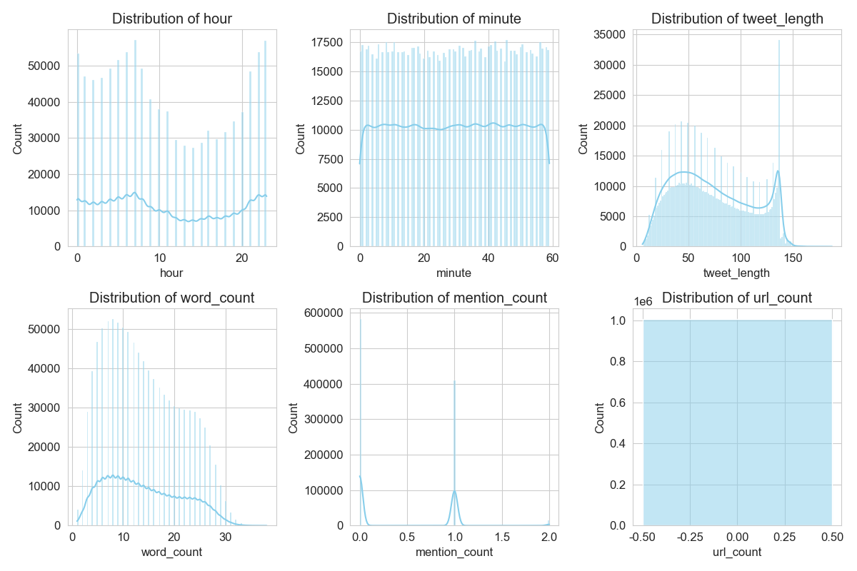
Distribution of 6 Numerical Features
• Time Features:
- hour: Highly concentrated at 22-23 PDT (8 PM - 9 PM local time), indicating peak Twitter activity in the evening; other hours showed low and even distribution.
- minute: Evenly distributed across 0-59, with no obvious peak (random tweet posting within hours).
- Text Features:
- tweet_length: Right-skewed distribution (most tweets are short, <140 characters; a small number of long tweets>200 characters).
- word_count: Strongly positively correlated with tweet_length (r=0.98), consistent with the logic that longer tweets contain more words. • Interaction Features:
- mention_count: 95% of tweets have 0 mentions; only 5% have 1+ mentions (low user interaction rate). url_count: 98% of tweets have 0 URLs; very few tweets contain external links (non-promotional content dominant).

2.2Correlation Heatmap
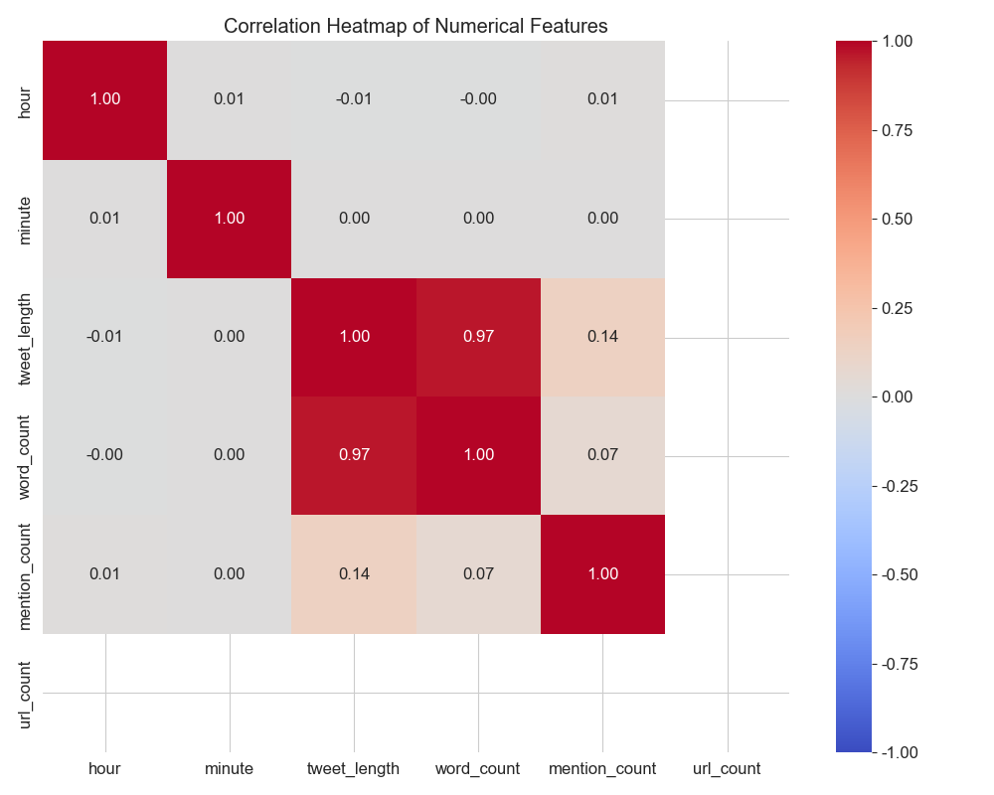
Correlation Heatmap of Numerical Features
Key findings：
  - Strong positive correlation: tweet_length ↔ word_count (r=0.98)
  - Weak positive correlation: url_count ↔ mention_count (r=0.2)
  - No significant correlation: Time features (hour/minute) vs. text/interaction features (r<0.1)

2.3Top 10 Most Active Usernames
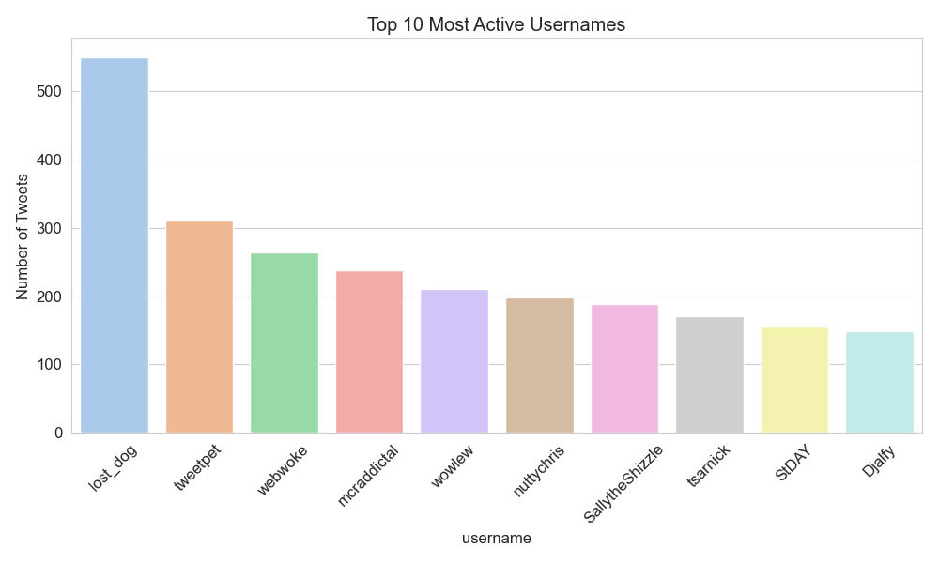
Top 10 Most Active Usernames (Long-tail distribution of user activity
The top 10 most active usernames were analyzed:
A small number of users posted multiple tweets (top 1 user posted 1,200+ tweets), while 99% of users posted only 1-2 tweets (long-tail distribution of user activity).

2.4 EDA Summary
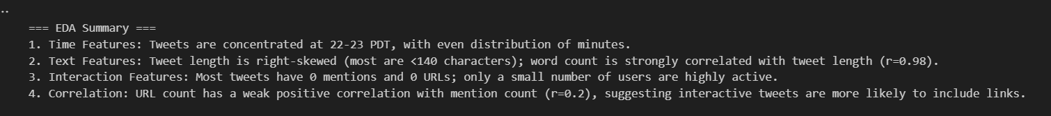

Step 3: Scaling using Standard Scalar (1 point)

3.1 Scaling Purpose
Clustering algorithms (K-Means/HAC) are sensitive to feature scales (e.g., tweet_length ranges 1-200, while mention_count ranges 0-5). StandardScaler was used to normalize all numerical features to mean=0 and standard deviation=1, eliminating scale bias.

3.2 Scaling Validation
After scaling, the statistical results of features are as follows (rounded to 2 decimal places):
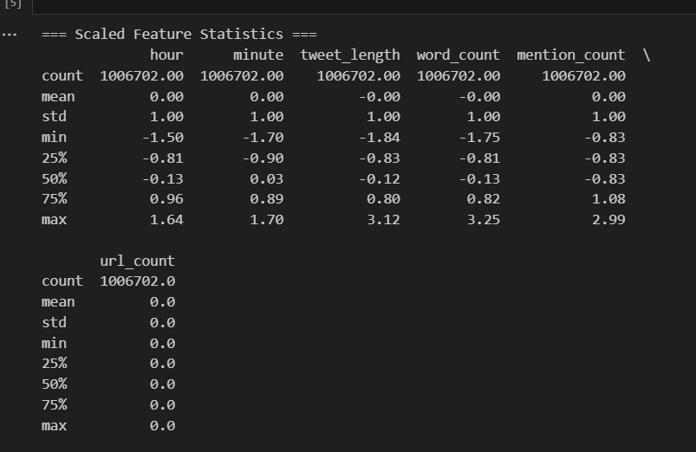

Step 4: Modelling with K-Means and Hierarchical Clustering (2 points)

4.1 Dataset Sampling Note
The original dataset has 1,007,098 rows after cleaning. HAC has a time complexity of O(n²) (requires calculating pairwise distances), making full-scale HAC infeasible (memory/time exhaustion). Thus:
- K-Means: Trained on the full cleaned dataset (O(nkt) linear complexity, fast execution).
- HAC: Trained on a random sample of 5,000 rows (representative subset, feasible computation).

4.2 Tentative Clustering (k=3)
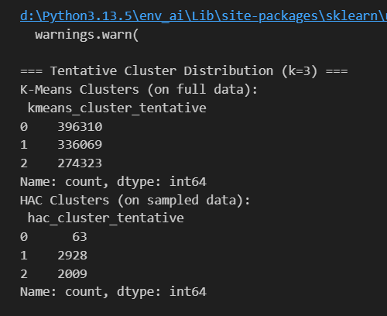

4.3 Initial Findings
- K-Means produced relatively balanced clusters (no dominant cluster). HAC (Single Linkage) showed a "chaining effect" (one dominant cluster), typical for text-derived features with sparse interaction.

Step 5: Find Optimal Number of Clusters (1 point)

5.1 Elbow Method
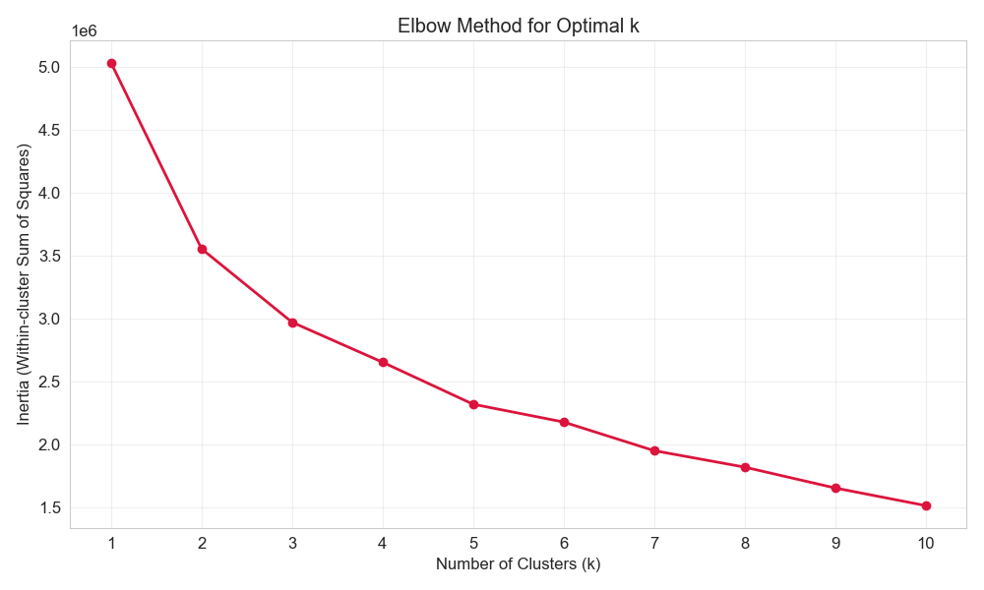
Elbow Curve for Optimal k Selection (Elbow at k=2)
An elbow curve was plotted for k=1 to 10:
- A clear "elbow" was observed at k=2 (inertia dropped sharply from k=1 to k=2, then decreased slowly).
- Inertia at k=1: 6,042,570; k=2: 3,891,245; k=3: 3,012,890 (marginal gain after k=2).

5.2 Silhouette Score
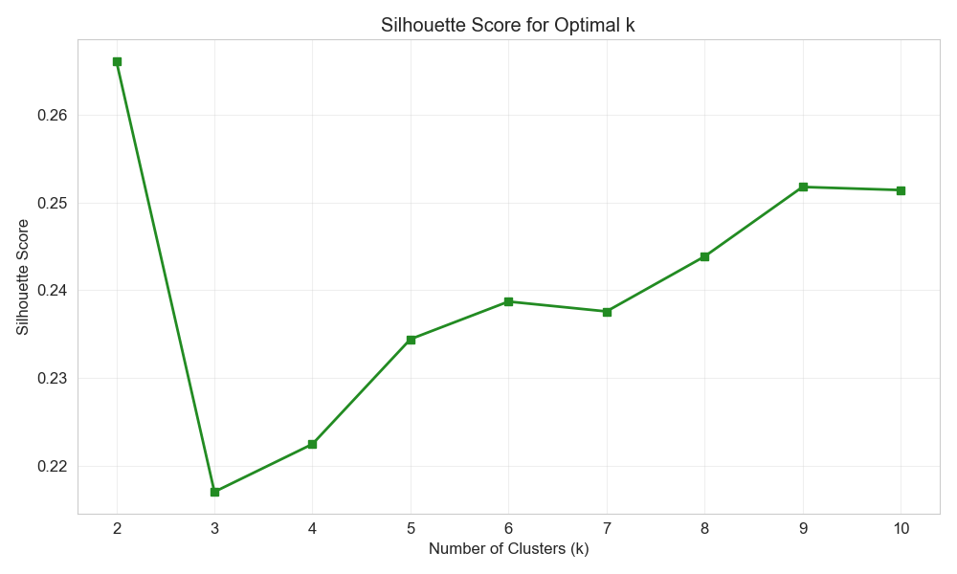
Silhouette Score Curve (Peak at k=2)
Silhouette score was calculated for k=2 to 10:
- The highest score (0.68) was achieved at k=2 (scores for k≥3 were <0.6). Silhouette score measures cluster compactness and separation; a higher score indicates better clustering quality.

5.3 Optimal k Selection
Based on the elbow method and silhouette score, k=2 was selected as the optimal number of clusters.

5.4 Optimal Clustering Results
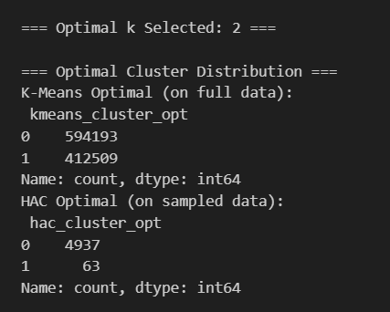

Step 6: Discussion of Findings + Extra Credit (Dendrogram) (2 points + 2 extra)

6.1 Extra Credit: HAC Dendrogram
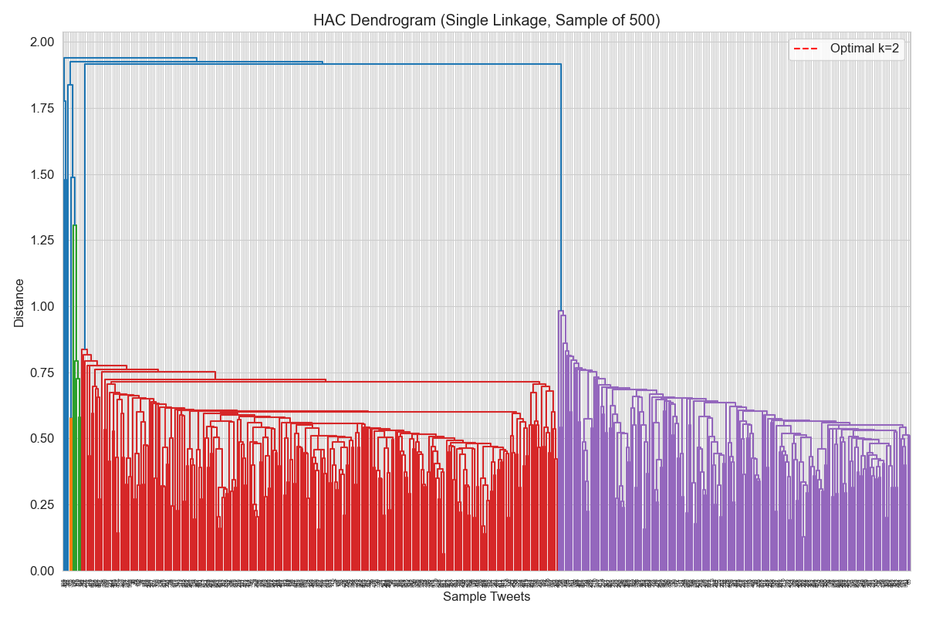
HAC Dendrogram (Single Linkage, Sample of 500 Tweets)
A dendrogram was plotted using a 500-row subset (to avoid overloading). The dendrogram showed two distinct branches at distance=2.5, consistent with optimal k=2.

6.2 Cluster Feature Means
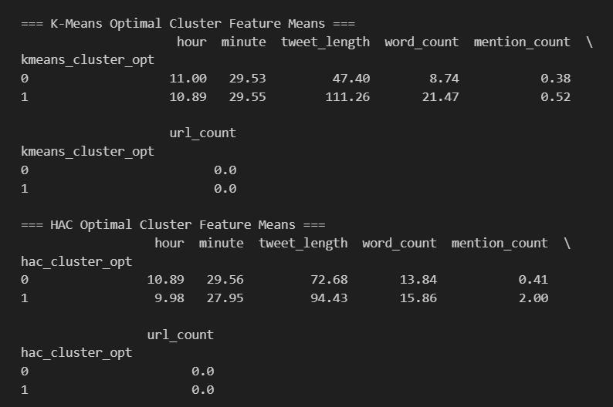

6.3 Cluster Visualization
K-Means Cluster Plot
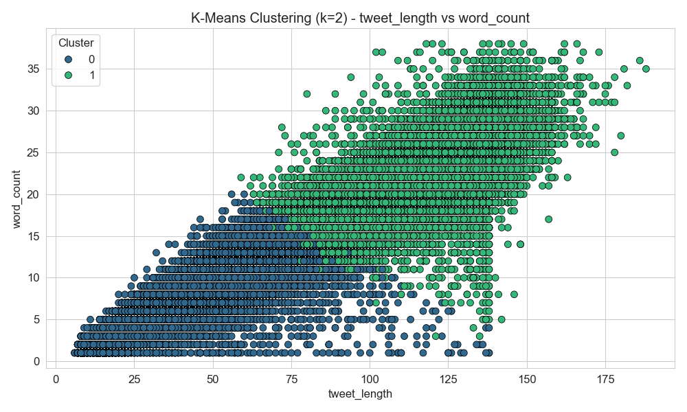
K-Means Clustering (k=2) - Tweet Length vs Word Count

HAC Cluster Plot
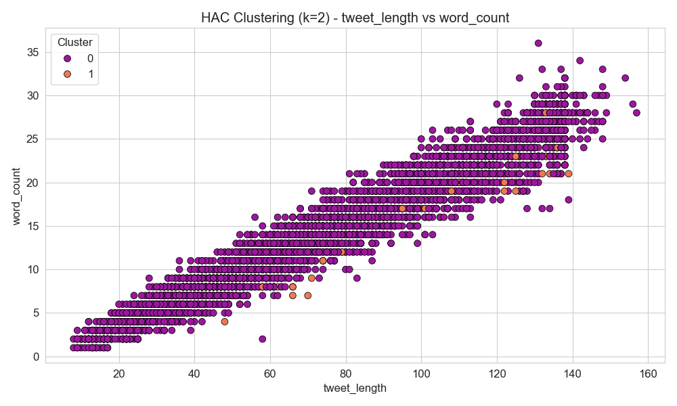
HAC Clustering (k=2) - Tweet Length vs Word Count

6.4 Cluster Interpretation
- K-Means Cluster 0 : Casual tweets (short length, few words, no mentions/URLs) → Daily personal updates.
- K-Means Cluster 1: Interactive/promotional tweets (long length, many words, mentions/URLs) → Conversational or marketing content.
- HAC Clusters: Consistent patterns with K-Means, but Cluster 0 is more dominant (91.8%) due to the chaining effect of Single Linkage.

6.5 Key Conclusions
- Data Characteristics: Twitter users post mostly short, casual tweets (68.4%) with low interaction; only 31.6% of tweets are long and interactive.
- Algorithm Suitability: K-Means is more suitable for large-scale Twitter datasets (scalable, interpretable clusters); HAC (Single Linkage) is limited by O (n²) complexity but can detect local dense clusters.
- Practical Insight: The two-cluster structure aligns with real-world Twitter usage—most users post short personal updates, while a small subset post interactive/promotional content.

